SOS, SESSION 2026 & ONWARDS

SHAHEED BENAZIR BHUTTO WOMEN UNIVERSITY
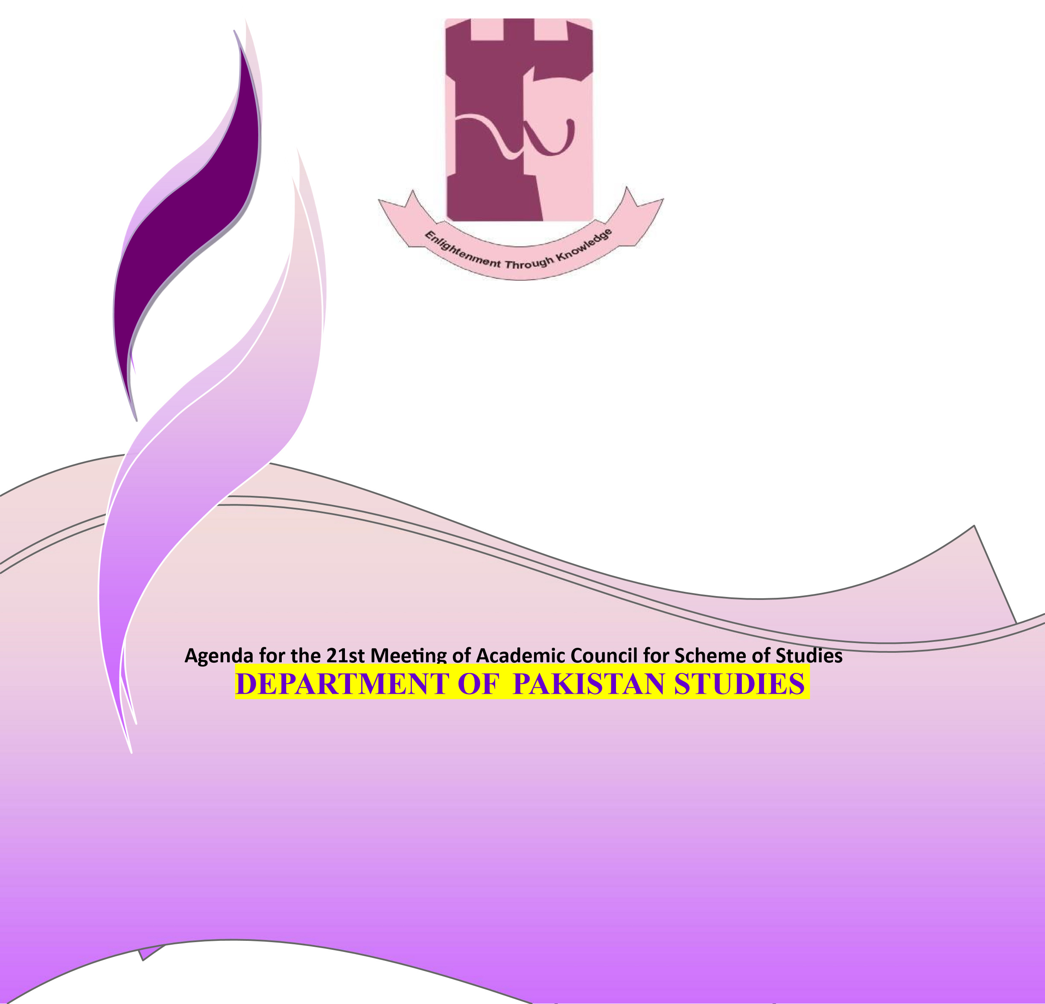
PESHAWAR

SHAHEED BENAZIR BHUTTO WOMEN UNIVERSITY PESHAWAR
DEPARTMENT OF PAKISTAN STUDIES

Department Curriculum Committee


Dr. Hamida Bibi 2. Ms Hina Bahadur
(Incharge/Assistant Professor) (Lecturer)

Submitted by: Dr Hamida Bibi
Incharge Department of History and Pakistan Studies,
Shaheed Benazir Bhutto Women University Peshawar

DEPARTMENT OF PAKISTAN STUDIES
Shaheed Benazir Bhutto Women University Peshawar

Vision Statement of Department
The Department prioritized vision is to produce sophisticated women scholars who will one day make a global difference by polishing and ostentation women scholar.

Mission Statement of Department
Our mission is promoting the skill of critical, creative and out of the box thinking in students. Our cardinal mission is to induce such graduates who can work for the benefit of humanity in general and Pakistan in particular. Our subsidiary mission is to produce professionals to uplift our environment and community through leadership.



SCHEME FOR
UNDERGRADUATE PROGRAM IN PAKISTAN STUDIES (BS PAKISTAN STUDIES)

DEPARTMENT OF HISTORY AND PAKISTAN
STUDIES Shaheed Benazir Bhutto Women University
Peshawar Session 2025 & Onwards

Admission Requirement for the BS program in Pakistan Studies

ELIGIBILITY
- Intermediate with at least 45% marks in aggregate

DURATION
- Four-year programme (8 Semesters)

DEGREE REQUIREMENT
- As per the University Revised Semester Regulations, a total number of 120144 Credit hours.

SHAHEED BENAZIR BHUTTO WOMEN UNIVERSITY PESHAWAR

Revised Scheme of Studies as per HEC New UGRAD POLICY2023 for the session 2025

STRUCTURE

S  r  . | Categories | Credit  Hours  Min –Max
1  . | General Education (Gen Edu) Requirements: Mandatory Courses of General Education. | 30 – 30
2  . | Major (Disciplinary) Requirements: Area of Study in Which the Degree is offered | *72 ≥
3  . | Interdisciplinary/Allied Requirements (To Support Horizon of the Major) | **12 ≥
4  . | Field Experience/Internship (Practical Work Experience related to a Student’s Field of Study or Career interest) | 03 – 03
5  . | Capstone Project or Capstone Research Project | 03 – 06
 | Tota | 120 – 144
*The Credit Hours for the courses of Major Disciplines may vary but not less than 72 Credit Hours.
**The Credit Hours for Interdisciplinary/Allied Courses may vary but not less than 12 Credit Hours.

- Total number of Credit hours 120-144
- Duration 4years
- Semester duration 16-18weeks
- Semesters 8
- Course Load per Semester 15-18 Cr hr
- Number of courses per semester 4-6 (not more than 3 lab/ practical courses)

SCHEME OF STUDIES OF BS -_PAKISTAN STUDIES__4-YEAR PROGRAM (SESSION
2025 & Onwards)

Semester | Category | Course Codes | Course Title | Lectures | Lab | Cr.Hrs
Semester 1 | Art & Humanities |  | From the prescribed list | 02 |  | 02
 | Islamic Studies/Religious  Studies/Ethics | ISL-301 | Islamic Studies (OR)  Religious  Education/Ethics in lieu of Islamic Studies only for non-Muslim students | 02 |  | 02
 | Ideology and Constitution of Pakistan | PST-313 | Ideology and Constitution of Pakistan | 02 |  | 02
 | Interdisciplinary/Allied | PSC-401 | Basic Concepts of  Political Science | 03 |  | 03
 | Functional English | ENG-303 | Functional English | 03 |  | 03
 | Major I | PST-311 | Geography of Pakistan | 03 |  | 03
 | Major II | PST-312 | A Survey Course of Muslim  Rule in Sub- Continent  (712-1526) | 03 |  | 03
 |  |  | Total |  |  | 18
Semester 2 | Social Sciences |  | From the prescribed list | 02 |  | 02
 | Pakistan Studies | PST-323 | Pakistan Studies | 02 |  | 02
 | Fehm-ul-Quran I | ISL-325 | Fehm-ul-Quran I | 01 |  | 01
 | Expository Writing | ENG-303 | Functional English | 03 |  | 03
 | Interdisciplinary/Allied |  | Artificial Intelligence AI | 03 |  | 03
 | Major III | PST-321 | A Survey Course of Muslim  Rule in Sub – Continent (1526-1857) | 03 |  | 03
 | Major IV | PST-322 | Human Rights in Pakistan | 03 |  | 03
 |  |  | Total |  |  | 17
Semester 3 | Quantitative Reasoning  (QR I) | MTH-401 | Quantitative Reasoning, I | 3 |  | 03
 | Application of Information and Communication Technologies. | CSC-308 | Application  Information and  Communication  Technologies | 2 | 01 | (2+1) 03
 | Fehm-ul-Quran II |  | Fehm-ul-Quran II | 01 |  | 01
 | Natural Science |  | From the prescribed list | 03 |  | 03
 | Entrepreneurship | MS-309 | Introduction to Entrepreneurship | 02 |  | 02
 | Major V | PST-421 | Pakistani Society and  Culture | 03 |  | 03
 | Major VI* | PST-422 | Muslim Freedom  Movement in India  (18571947) | 03 |  | 03

 |  |  |  |  |  |  |  |  |  |  | Total |  |  | 18
Semester 4 | Civic and Community  Engagement |  |  |  |  |  |  |  |  | PSC-418 | Civics and Community  Engagement | 2 |  | 02
 | Quantitative Reasoning  (QR II) |  |  |  |  |  |  |  |  | MTH-402 | Quantitative Reasoning,  II | 3 |  | 03
 | Major VII |  |  |  |  |  |  |  |  | PST-424 | Economic development of  Pakistan | 03 |  | 03
 | Major VIII |  |  |  |  |  |  |  |  | PST-425 | Ancient Pakistan:  Mehargarh, Indus and  Gandhara Civilizations | 03 |  | 03
 | Major IX |  |  |  |  |  |  |  |  | PST-426 | Pakistan: Government and  Politics | 03 |  | 03
 | Major X |  |  |  |  |  |  |  |  | PST-427 | Demographic  Profile of Pakistan | 03 |  | 03
 |  |  |  |  |  |  |  |  |  |  | Total |  |  | 17
Semester 5 | Interdisciplinary/Allied  Course |  |  |  |  |  |  |  |  | PSC-402 | Basic Concepts in  International Relations | 03 |  | 03
 | Interdisciplinary/Allied  Course |  |  |  |  |  |  |  |  | PST-535 | History and Politics of  Khyber Pakhtunkhwa  (1901-1947) | 03 |  | 03
 | Major XI |  |  |  |  |  |  |  |  | PST-531 | Pakistan’s National Security:  External & Internal  Dimensions | 03 |  | 03
 | Major XII |  |  |  |  |  |  |  |  | PST-533 | Political and Constitutional  Development in Pakistan  (1947-1973) | 03 |  | 03
 | Major XVII |  |  |  |  |  |  |  |  | PST-539 | Ideological Foundation of  Pakistan | 03 |  | 03
 | Major XIIV |  |  |  |  |  |  |  |  | PST-532 | Social Change and Development in Pakistan | 03 |  | 03
 |  |  |  |  |  |  |  |  |  |  |  |  |  | 18
Semester 6 | Major XV |  |  |  |  |  |  |  |  | PST-537 | Research Methods and  Techniques | 03 |  | 03
 | Major XIII |  |  |  |  |  |  |  |  | PST-534 | Foreign Policy of Pakistan | 03 |  | 03
 | Major XVI |  |  |  |  |  |  |  |  | PST- 538 | Political and Constitutional  Development in Pakistan  (1973-Onwards) | 03 |  | 03
 | Major XVIII |  |  |  |  |  |  |  |  | PST-540 | Pakistani Languages and literature | 03 |  | 03
 | Major XIX |  |  |  |  |  |  |  |  | PST-541 | Local Government System in Pakistan | 03 |  | 03
 | Major XX |  |  |  |  |  |  |  |  | PST- | Elective | 03 |  | 03
 |  |  |  |  |  |  |  |  |  |  | Total |  |  | 18
Semester 7 | Internship (Mandator |  |  |  |  |  | y) |  |  | PST-698 | To be conducted in summer and report to be written in  7th Semester | 03 |  | 03
 |  |  |  | Major XXI (Elective) |  |  |  |  |  | PST- | Elective | 03 |  | 03
 | Major XXII |  |  |  |  |  |  |  |  | PST-641 | Major Political Parties in  Pakistan | 03 |  | 03
 | Major XXIII |  |  |  |  |  |  |  |  | PST-642 | Civil Society in Pakistan | 03 |  | 03
 | Major XXIV |  |  |  |  |  |  |  |  | PST-643 | Geopolitics of Pakistan | 03 |  | 03
 |  | Capstone Research Proj |  |  |  |  | ect |  |  | PST-699  PST-697 | Capstone Research Project or Elective Course | 03 |  | 03
OR
Elective Course
 |  |  |  |  |  |  |  |  |  |  |  |  |  | 18
Semester 8 |  |  | Major XXV (Elective) |  |  |  |  |  |  | PST- | Elective | 03 |  | 03
 | Major XXVI |  |  |  |  |  |  |  |  | PST- | Elective | 03 |  | 03
 | Major XXVII |  |  |  |  |  |  |  |  | PST-645 | Pakistan Relations with  Muslim World | 03 |  | 03
 | Major XXVIII Electiv |  |  |  |  |  | e |  |  | PST- | Elective
 |  | Capstone Research Proj  Or Research |  |  |  |  | ect |  |  | PST-  PST- | Capstone Research Project  Or Research | 3 |  | 03
 |  |  |  |  |  |  |  |  |  |  | Total Cr. Hrs. |  |  | 15

S.NO | Course Codes | List Of Elective Subject | Credit Hours
1 | PST-542 | Issues of governance in Pakistan | 3
2 | PST-543 | Archaeology of Pakistan | 3
3 | PST-544 | Public Administration in Pakistan | 3
4 | PST-545 | Pakistan and Neighbors | 3
5 | PST-646 | Cultural Diversity of Pakistan | 3
6 | PST-647 | Women Empowerment in Pakistan | 3
7 | PST-648 | Political Economy of Pakistan | 3
8 | PST-649 | Urbanization in Pakistan | 3
9 | PST-650 | Pakistan Relations with Russia | 3
10 | PST-651 | Pak-China Relations | 3
11 | PST-652 | Environmental Problems of Pakistan | 3
12 | PST-653 | Urbanization in Pakistan | 3
13 | PST-651 | Seminar on Contemporary Issues in Pakistan | 3

1. To approve the following courses to be offered for other departments presented as Agenda item No. II, as per recommendation/modifications of Members of the Board of Faculty. The members approved the offered for other departments unanimously.

